Southwest University
School of Computer & Information Science

Experiment Report

Course： Unix/Linux环境实践
Topic ：
Grade&class：Grade 2018 Class SE1
Student Name： 宋行健
Submission Date： 2020年12月14日
第十二章课后题（P312）
1. Run a command as root to watch the /var/log/messages file and insert your USB flash drive. Determine the device name of the USB flash drive.
- lsblk 列出当前块设备，可以查看U盘名。
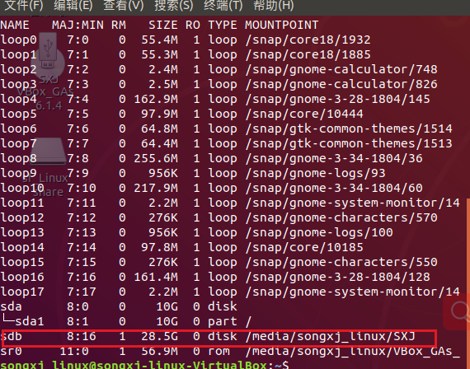
2. Run a command to list the partition table for the USB flash drive.
- fdisk -l /dev/sdb
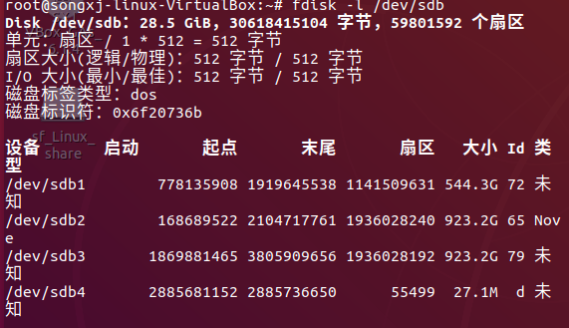
3. Delete all the partitions on your USB flash drive, save the changes, and make sure the changes were made both on the disk’s partition table and in the Linux kernel.
- 使用fdisk进入磁盘操作命令，之后选择d操作并依次输入分区号。
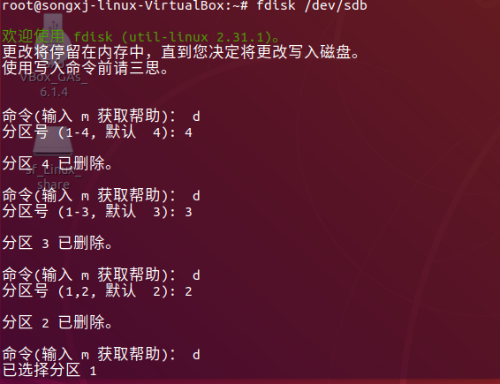
4. Add three partitions to the USB flash drive: 100MB Linux partition, 200MB swap partition, and 500MB LVM partition. Save the changes.
- 创建一个Linux分区：
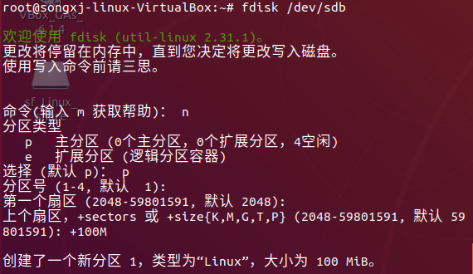
- 创建第二个Linux分区，并将其通过t命令（82）变成swap partition：
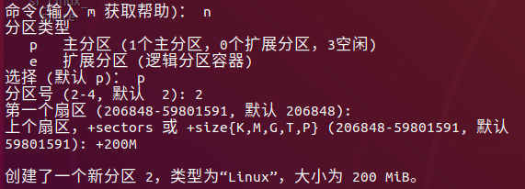
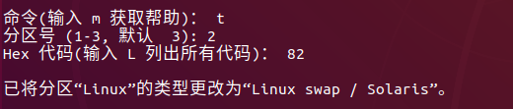
- 创建第三个Linux分区，并使用t命令（8e）将其变成LVM partition：
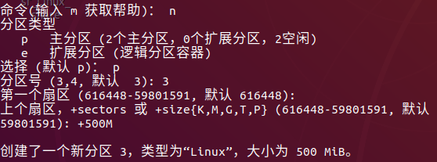

- 展示分区结果：
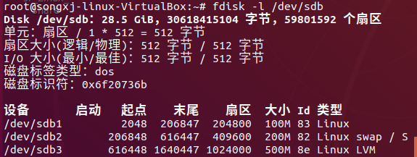
5. Put an ext3 filesystem on the Linux partition.
- partprobe /dev/sdb partprobe 是一个可以修改kernel中分区表的工具，可以使kernel重新读取分区表而不用重启系统。
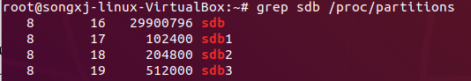
- mkfs -t ext3 /dev/sdb1 将sdb1分区格式化为ext3格式
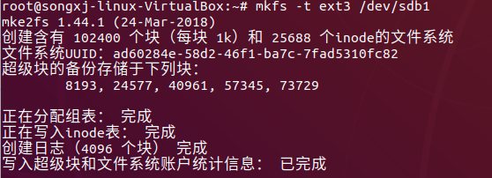
6. Create a mount point called /mnt/mypart, and mount the Linux partition on it.
- mkdir /mnt/mypart 创建一个新文件夹
- mount -t ext3 /dev/sdb1 /mnt/mypart 将其按照ext3格式挂载在sdb1分区
7. Enable the swap partition, and turn it on so additional swap space is immediately available.
- mkswap /dev/sdb2 设置交换区
- swapon /dev/sdb2 激活Linux系统中交换空间，Linux系统的内存管理必须使用交换区来建立虚拟内存。
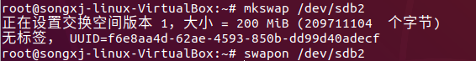
8. Create a volume group called abc from the LVM partition, create a 200MB logical volume from that group called data, add a VFAT partition, and then temporarily mount the logical volume on a new directory named /mnt/test . Check that it was successfully mounted.
- pvcreate /dev/sdb3 将物理硬盘分区初始化为物理卷，以便LVM使用。
- vgcreate abc /dev/sdb3 创建LVM卷组。卷组（Volume Group）将多个物理卷组织成一个整体，屏蔽了底层物理卷细节。在卷组上创建逻辑卷时不用考虑具体的物理卷信息。
- lvcreate -n data -L 200M abc 创建LVM的逻辑卷。逻辑卷是创建在卷组之上的。-L 指定逻辑卷的大小为200M
- mkfs -t vfat /dev/mapper/abc-data 在特定的分区上建立Linux文件系统
- mkdir /mnt/test
- mount /dev/mapper/abc-data /mnt/test
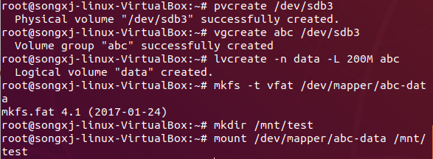
9. Grow the logical volume from 200MB to 300MB.
- lvextend -L +100M /dev/mapper/abc-data 在线扩展逻辑卷的空间大小，而不中断应用程序对逻辑卷的访问。
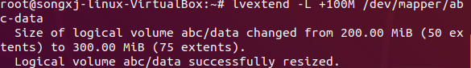
- resize2fs -p /dev/mapper/abc-data 增大或者收缩未加载的“ext2/ext3”文件系统的大小。
10. Do what you need to do to safely remove the USB flash drive from the computer: unmount the Linux partition, turn off the swap partition, unmount the logical volume, and delete the volume group from the USB flash drive.
- umount /dev/sdb1 卸除目前挂在Linux目录中的文件系统
- swapoff /dev/sdb2 关闭系统的交换区
- umount /mnt/test
- lvremove /dev/mapper/abc-data 删除指定LVM逻辑卷
- vgremove abc 删除LVM卷组
- pvremove /dev/sdb3 删除一个存在的物理卷
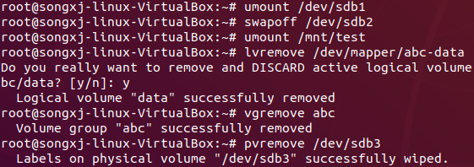

第十章课后题（P258）

YUM方法
1. Search the YUM repository for the package that provides the mogrify command.
- yum provides mogrify 查找软件所属的软件包
2. Display information about the package that provides the mogrify command and determine what that package’s home page (URL) is.
- yum info ImageMagick 显示有关提供mogrify命令的包的信息
3. Install the package containing the mogrify command.
- yum install ImageMagick 安装

RPM方法
4. List all the documentation fi les contained in the package that provides the mogrify command.
- rpm -qd ImageMagick 列出提供mogrify命令的包中包含的所有文档文件
5. Look through the changelog of the package that provides the mogrify command.
- rpm -q --changelog ImageMagick | less
6. Delete the mogrify command from your system, and verify its package against the RPM database to see that the command is indeed missing.
- type mogrify
- rm /usr/bin/mogrify
- rpm -V ImageMagick
7. Reinstall the package that provides the mogrify command, and make sure the entire package is intact again.
- yum reinstall ImageMagick
- rpm -V ImageMagick

Score：

Teacher（signature）：

Date:

